*Project Initiation:*

*Introduction:*

This is the specific document to cover the project initiation. From what I gathered, it is just a collection of all previous information gathered from the previous documents.

*Why do we need to undertake this project?*

The project needs to be undertaken/completed as it is required in terms of grading. At the end of this project, if completed to a high standard, all team members will gain an effective and improved grade which will improve their overall unique personal grade.

*What are the business benefits?*

There are many different business benefits to completing this project. For example, completing this project and publicly publishing or having it noted by the public figure will allow for the individual representation of each team member to improve and will help each individual team member find future work or educational stipulations.

*What are the risks?*

There is not any direct associated with the project. It will not harm the overall team members directly in a business/finical way but may hinder their ability to achieve a rewarding grade at the end of the marked project. There are also health risks meaning that all team members need to make sure that they follow effective health and safety when using a technological device.

The overall project may not be maintainable long-term depending on what software and systems we use, so the team members will have evaluated the specifically used software and devices to see if they can be maintained for future implementation.

*What are the potential costs?*

As far as I can tell, there is no potential costs regarding the project. The project is not using any paid content and all software and devices used have either been bought in a matter unrelated to the project or are free or have a free trial system.

*How long will the project take?*

I am not entirely sure how long the project will take. The only accurate estimation I can make is that it will either take less time than the dedicated deadline or it will take the maximum amount of time stipulated by the deadline.

*Project Description:*

*Introduction:*

This is the specific document to cover the product description, so any external party can get a clear overview of the project and what it is specifically intended to do.

*Purpose:*

The purpose of the project is to create and develop a specific application/software which can simulate viral infections using the SIR infection model. It will also, as a sub add on, inform people about viral transmissions and the specific attributes related to how a virus transmits.

*Acceptance method and responsibility:*

The responsibility will be along all members of the team to quality check, analysis, fix and update specific parts of the application/software and make sure that the project is the best it can possibly it can be.

*Customer Quality Expectations:*

To validate customer quality and the systems, a form can be sent out to users to ask for feedback, or feedback can be interpreted from specific sections inside of the Github repository. There can also be a feedback system built inside of the application.

*Project Brief:*

*Introduction:*

This is the specific document to cover the project brief. This is simply just a combination of two pre-existing documents.

*Purpose:*

The purpose of the project is to create and develop a specific application/software which can simulate viral infections using the SIR infection model. It will also, as a sub add on, inform people about viral transmissions and the specific attributes related to how a virus transmits.

*Acceptance method and responsibility:*

The responsibility will be along all members of the team to quality check, analysis, fix and update specific parts of the application/software and make sure that the project is the best it can possibly it can be.

*Customer Quality Expectations:*

To validate customer quality and the systems, a form can be sent out to users to ask for feedback, or feedback can be interpreted from specific sections inside of the Github repository. There can also be a feedback system built inside of the application.

*Project Team:*

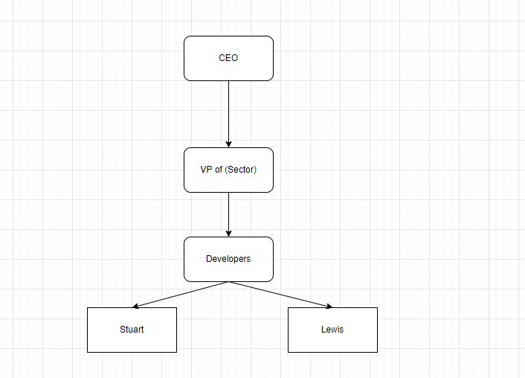

*Project Mandate:*

*Introduction:*

This is the specific document to cover the initial formatting of the overall project. It will contain key sections required to allow members of the team to understand what is being completed and why. Specifically doing this now also allows for reduced work later and reduced confusion because of that the fact that the core information is easily accessible.

*Project Scope:*

The current project is about the SIR model and producing a functional application/software to allow an end user to simulate an infection in a specific location and to see how the infection would function in the specific virtual environment.

*Project Objectives:*

This section will be updated as required because project objectives may change based on changes in external markets, clients or internal stipulations. As of current, the required objectives that the application need to complete are as followed:

* The project needs to have a completed documentation regardless of the state of the project whether in quality, quantity, or completion.
* The project needs to, if possible, be able to complete basic required tasks in processing data and producing the desired output.
* The project should be able to be cost effective and not be resource intensive.

*Roles and Responsibilities:*

There will not by any direct roles and responsibilities. The reason being is that the overall team list as of current is too small (overall team members is currently 2), meaning that having specific roles will not be beneficial, it will more so be a hindrance.

*Reasons:*

The specific reason that this project is being completed is the fact that it is required. Without this specific completion, a failing grade will be passed lowering the overall ranking of each member’s personal graded record.

This specific application was made because this specific formula is used a lot, especially in the current times because a lot of viral transmissions occur and viral related issues. Using this current issue, an application could be developed to teach people about specific viral transmission and how specific attributes of viruses can make them deadlier.

*Key Constraints:*

The key constraints regarding the project are mainly time and knowledge. Obviously, the project has a deadline meaning that it needs to be completed by then otherwise the grade might be capped. This becomes difficult though because of active exams, concurrent assignments and active work being set in college hours.

Knowledge is also reduced and becomes an issue as well. None of the team have created an application/software like this, in fact they have not created an application like this before. A key premise in terms of the development of the project is that knowledge of programming and developing an application to fill this specific format must be increased.